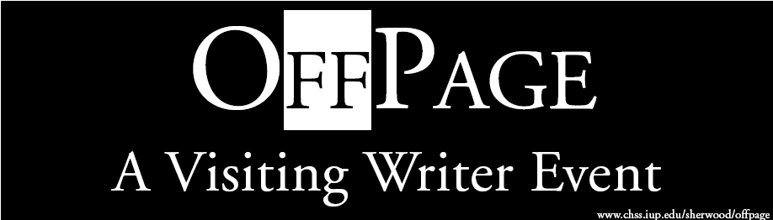
Rachel Blau DuPlessis

Monday, March 14, 2005
8pm - Commonplace Coffeehouse
(University Square on Grant St.)

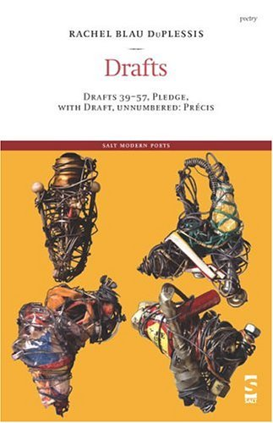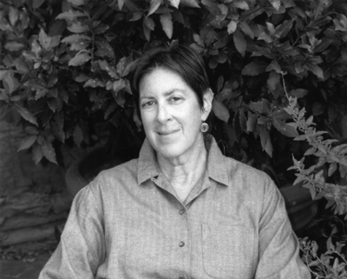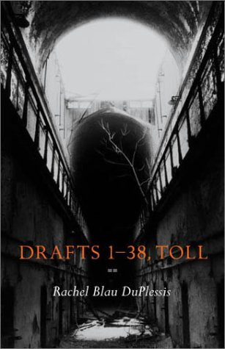

Rachel Blau DuPlessis has published over a dozen books, including 8 volumes of poetry, 4 volumes of criticism, and several edited collections. Known as an innovative poet and a major feminist thinker, she is a Professor of English at Temple University and has been recognized by the PA Council on the Arts, the Fund for Poetry, Archive for New Poetry, and the Pew Foundation.

From: Wells. Montemora Press, 1980.

http://www.durationpress.com/archives/rduplessis/wells.pdf

Leaving One Place for Another
These furnished places
the sky a white screen
the powerful image
and accident.
What was it what part
of the body why talk Silence
surrounds these instincts
I leaned out of the window.
In the back of my mind you
with your cigarette
hunched over it
and others arrested like that,
the same river in six cities.

A Poem of Myself
Sometimes I cannot move at all and will not either

I imagine myself looking over a group of hills somewhere else, away.
In Italy.

The trees begin swaying as I watch them
Turning inward and outward onto myself.

No. I am sitting on a terrace and no one is bothering me.

Standing in entrances. About to come in.
My shoulders are hunched forward to hide my breasts.
When am I going to come into the room?

Come in, come in, I say to all the fragments

“Whirr Shrill Crickets”

Whirr shrill crickets
cicadas
Silvery
field disc bright that seeds itself
;
:
:
everyday bud.

Put your nose into the flower, you
are shivering
some soft bird wood

voice

hidden in the teeming answering
from no one point.

And bottomless the field of night.

Because
awakened stones are with us
thirsty
in the light of stars.

Black and white
black and white
wave after wave the ocean hisses black
field white field a place not
a place but crossings, distances
into

To take
and hold
one water bright stone

red pink green

names

The small waves’ names the grass
-wheat
bud thin molecules
flesh into the
light

What will protect us from pleasure?

To breathe the air rushing us forward

Open night sky nothing
stands between the self and its
disappearance

It is already a star

This is JACKET # 14 - July 2001 | # 14 CONTENTS | HOMEPAGE http://jacketmagazine.com/14/duplessis.html

Rachel Blau DuPlessis

Draft 42: Epistle, Studios
You can read Patrick Pritchett’s review of Drafts 1-38, Toll in Jacket 22.
Somewhere between jouer and jouir is this pleasure
forage language, form letters
of writing parallel
lurches, vocabularies that come across, or don’t.
We are writing — to the other?
but bent, a band of odd light refracts back.
Flat mist view, you tell me bits of your past and project
a socked-in sky, a bottle corked you said “bouché” your grey
La Rochelle weather and then we got it,
sea fret over Italy — the shaking dew.
We hardly know each other.
In fact.
So when you write me what you
think I am seeing
from my stone studio window
“projecting future memory,”
it’s your unwritten memoir of Italy
to conjure what has
not yet happened one full day and site —
and you’re partly right!
The hot gold & thick green
felix (quondam) pecus, platters of plenty —
these findings fuse to
proleptic nostalgias —
friendship
making one nostalgic for another person’s present
(also presence) —
so (as you said) you are working
to compose beforehand,
in advance,
the folded fields and hills
the misty afa green, the wheaten rise
the clarity of little occasions and choices
solidified in the act of the built —
of the Bilt —
sandstone mortared with silt
brightened chips of brick someone once,
bricolaging, reached for
that you imagine you will find
stone stanza
here (somewhere else, away),
whenever you and Kathy
(and maybe Yves) do visit.
Donor panels are folded
across the hidden scene.
Every day a digging out or in, each day a change.
Every night a speckled time engulfed.
Yet we will meet again, we both swear it
and we will drink, never sending the wine back,
will tempera the full
“moon afloat in the carp pond” —
allusive praedella of Cathay.
What I see from the stone is time’s
unrolling scroll
one’s hand shakes to write.
Every word teeming and bereft
within its unremarked extent, its ebb and eddy.
Yet we both remember that multi-lingual renga!
Tomlinson, Roubaud, Paz, and Sanguineti
each in his language langue or lingua
loom working weights and filaments, words
as lingo — the shuttle patterning, the treadle clattering —
co-workers in the expert turns of torque and tension.
So when you said, half a translation, about my “Renga”
“Mémoire, Mnemosyne, souvenir d’avance d’un temps
irrésolu avançant vers
sa résolution”
I didn’t know
who or whom wrote what.
What’s the historical status
of future memory?
Such riffs on “resolution”
and on forms of “avance”
the question of whether the “temps”
(weather and time and even, therefore, mood)
is “irrésolu”
or maybe the “advancing” is —
not to speak of the triple meaning of vers —
I can worm it out
with specific engorgements of words
and my inventions do rupture
the inestimable purities of gallic syntax
but I am filled with oddities and tensions
even things one cannot even note
motes and mites in your letter
that barely can be organized “in” anything
much less in writing.
“Well, they are gone, and here must I remain,
this lime-tree bower, my prison!”
awkwardly waving (over 5 ft. tall), green V-stalks,
yellow green fruiting out seeds,
and marking where hills make
an ever-variable line of valley dark
civil, nautical, astronomical twilights
whose triple incipience brings the mountain
motivic (its name is Acute)
closer at certain times
of day, and certain lights.
For all the clouds and enrapturing light and blue
all the white and grey luminosities, the translations streaming upward
are changing and reconstructing ceaselessly.
Eclipses of cloud-shadow cross the hills
buoyed by the prevailing winds.
Is this writing or memory? Projection or repetition?
Real or unreal? The memoir of me, or anti-memoir
against my real life? Which is
a georgic. As yours, too, seems to be
work work work like 7 dwarves.
You, in fact, translated me.
And your poems by me are so rich and dense
I cannot always understand them in the French.
Where I am it’s another self, patches of anti-me
with bits rooted and others floating free.
Which are the words and which are the shadows?
clouds pile and repile, frame and barrows,
hunger of incipience perpetual.
Are we friends? do we miss
each other’s implications?
Words stranger
in an old terraced field.
But still “on dialogue avec les pierres” you say
“On dort dans les pierres, en fait.
Et elles parlent
énormément de langues qui s’oublient
en s’énonçant.”
Spectra of tongues inside the very stones
a forgetting, a pronouncing
from shimmers of the molecular
they and us each others’ interlocutors.
Thus when I opened Essais: Quatre Poèmes
I wanted to translate the poems into English
as if French were their original,
and you had written them.
My impulse was to make
an entirely new work, one
not myself, but blown
to the side and then opening
simultaneous conflictual overloaded presences
a changeable pulse of mist, a
doubled poem, the verso of verso
variable/ variabile
a locus of difference, anyway,
by virtue of “translation” —
a cloud secret in another system of clouds.
Had I written everything you say?
invented hours that may as well
once have existed?
Had I written anything you say? Well —
not to go sentimental.
“Of course” “I” “had.”
But couldn’t really read me.
For what I had originally set, in this language,
and what I couldn’t get
of what you had done in your language
stood in my way.
There was the past of the past,
the paths of the past and their anti-paths,
there were complex sorrows and antipathies
that come from talking to stones
there was silence inside the chrysalis desire
there were words
no longer speakable
folded with us
in our proleptic ashes and tombs.
I think of Armand Schwerner, dead.
This is the Umbrian Canto
under a wide and starry sky
his taking the heaviest stones of that place
for a pillow.
To write the other side of
something that really happened
or something that didn’t, the anti-memoir
call it metaphor,
what would it contain
of the life I didn’t lead
pebbles dropped onto the paths
that lead to other lives,
the rocks on which
one tries, troubled, to sleep
and then, still fighting stillness,
wrestles rough-edged angels.
For if any point can act like a center
there is plenty of room
to study pressure
whenever it chooses to grapple with you
unto shock and separated bone,
to limp away into the depths of dawn,
and to improvise an oeuvre from overlays of
twilight, perplexed with being exilic
in all the places called
home
and in all the places never
visited, or never stayed.
For I write in three studios:
a saffron colored room of sky-blue far
buried map in front of I am R
a yellow room next
to it, and, barely translatable text,
a stone room in Italy
somewhere else, away.
Writing deictic in this here, wherever space,
whatever am I, writing now:
inside and broken on all errant, wandering place.
In the light yellow room adjacent,
(the guest room where you could,
if you came to the U.S., stay)
there’s a photo of Lady-dog moribund
black and white, leaking and weakening on newspapers
a day or two before we carried her weeping to the vet
and under this, its mysterious counterpart,
your New Year postcard, Mt. Huong Shan:
stark-rock precipices, clustered
the peaks almost totally effaced
by floods of opalescent mist
billowing airs
by never-ceasing cloud cascades
enfolding the stones
of what we claim
in shaping reckless living chains.

August-December 1999, March 2000
to Jean-Paul Auxeméry

http://english.chass.ncsu.edu/freeverse/Archives/Winter_2003/poems/R_Duplessis.htm

Rachel Blau DuPlessis
Draft 47: Printed Matter
Headlines. Canyoned rockfall of alphabetic signs and leached gemstones. Leaf Faceted
Tod. Pebbles and crumbs of bread, long trail. Scurrying Lens. Broken glass. Four colors:
sanguine, siena bruciata, terra d'ombra, and deep madder lake. Who dumped mercury-
tainted concrete? Cadmium Petals rattling. Turd erosion windform. Linked and locked by
depots. Dumps that burn up bode. Poison appel; prisoned nipple. Drinking industrial
waste. Extruded on a hill: stackwood. Oven flesh. Rath and late. Did you say range or
rage? "Fate" as politics under a false name. Ton. 2000 pound-year multiple exposure tree.
Infolded realism. Eclipse. Or abandonment. Mark PASQ.
Such small stakes
within the endless
"local conversation
in a universe of silence"
Starry oddity of any-
thing must speak of that.
Particular pre-dawn conjunctions:
Two wandering planets,
two pearly limpidities
match celestial longitude
along oblique orbits.
Strip mall recollected in tranquility.
And why not rage?
"Ford Wins Kennedy Award for
'Courage' of Nixon Pardon"
Headline 22 May 2001 must
speak of that.
Non-compliant glides below radar. Consolidation of pressured elites. Minor reward spin-
off. Crisis synthesis. Endless participation in Tainted Processes. Bloopy letters pastel
colored, outlined black. Mounded piles of scrap metal catch the light. Horny non-
dimensional underworlds. Rank body of the mother, mattering. Mutter it, mumble lost.
Nattering realism. Asterism--post-identity constellation dipper. Regeneration of the
cosmopolite. Haruspicating Liver as a good suburb, curved roads. Shopkeeper killed for
cash. The solid chunk of letter proctors mottoes. Torqued glossalalias and querelous
righteousness. Genocide Verdict for Ex-General. Industrial Grade Server needed.
Scavengers thought it fertilizer. Cross over, arrested. Is it keening or kenning? Mark
PASQ.
Incredibly important "debris and fragment"
difficult to grasp them
hard to perceive how
"the social
and historical dimensions
of our innermost selves"
flash small narratives in this labyrinth,
the so-called "labyrinth of history."
Want to say instead how fibers
carded, beaten, stretched and twisted
rope inside us innermost
want to hold the end of this thread
and turn ourselves inside out, descending
into corridors within the bodied mire
inside fingers grasping, inside grasp.
Fibers made of sound and shadow
from ourselves turned open-folded
in ourselves the maze.
Woven Flax both sides of the grave. Androgynous realism. Brackish water. Clustering
zebra whites, wind-blown, grapple onto lavender. Dug hermetic high-yield trenches.
Acres of black tires, set aflame. Is it manna or matter? Different hands and the spotted
horse. Nekuia in permanence. English as a foreign language. Argile Argive. Demand
matted hypnopompic skills. Erect that vagina. Codeine drip, blue slop dropped the dose
half in her angry mouth. Her dying. In real time, past time, vision time, in little, in dream
time. Who crafted official denials? Toxic chemicals leach into the water table. This
publication cannot be released. Change? Charity? Bio-tech patents and Pricing strategy.
Smudge on the wall, the embrasure flute-lip, little abutment. If you become your own
dead, what follows? Continuous Half-War; Headlines' titles hail us. Who is expendable?
Mark PASQ.
A trace of spotted light
whose source shines outside a closed door,
yet the light leaking through rents and cracks
through hinges and uneven fits into doorframe
spreads justifications and statistical auras.
There is a pattern to these arced droplets of light;
an imprint of matter, a recurrent sight
on the stone floor self on which self warily steps.
The government called the report back
as showing criminal complicity
of that same, our, government
in the massacre,
claimed the release was "in error"
but it was already up, readable on the website,
someone had put it up, all 830 pages of it,
overnight.
An incalculable ratio of pages
to dead.
Who put the lists into the hands of assassins? In the middle of invented hell. In deep
unwake. Stench of green mold fuzzed out round a rotting orange. Ball of potential
banging down the chuckle-headed corridor. Where it goes, it goes. Is it one-
third or one-fourth of all people in "severe poverty"? Was that gazed or glazed? "Burned fellow
villagers in a barn." Griots--kinds of human shadow tuned and timbred with particular
memory. That small tree grown from the back of his neck. Who leaked the documents?
Orphaned realism. Blind and bone-deformed children. Oedipalization a permeable
membrane through which osmosis saturates the raisin. Mouth her. Calenque knife cliff
bulbous sandstone. Is it scarp or scrap? Scurry or scry? Can you breathe? One Graffito
anyway was simple as pie: $$ on the wall. Mark PASQ.
Mode of "of"—asking what we are part of,
failed social justice.
Questing
in the allegorical
"light dress of a wayfarer"
ransacking the centuries more and more
disengaged and desperate,
more and more on trial
splitting open the locations of intensity
hoping to scry that other taking shape
beneath the white line of "the page"
inside the pixeled luminosity of "screen"
under the fecund bumps and rocks of "path"
through lumps of phosphorescence
from a rotting log
in order to engage a space beyond denial.
Find madder lake on the Colour Atlas. Dreamed words, unread. Butterfly schnozzle
nuzzling a scabious: orange-yellow on lavender-pink. Name in red-drawn outline flame.
Is it data or dada? Insurgent foreignness. Insistent triteness. Never enough to name;
explosive frustrations. Dream of watching ants lay eggs. Blowing flute note, plus his
voicing, drone and hum. Moth Fat. Vulvular zigzags. Imminent Streak or counterscore. A
hole a line a hold a lie a limn: largesse and held. Distribution of resources. Excellent
incentives and subsidies offered. Who planted land mines in that field? Behold: was
through! passage uncurtailed. Did you say scream or screen? Encaustic realism: Slice of
truth. Chromatic and funerary. Paragon? or Exacerbate? Mammal light foot engorged on
rock face. Figures ghostly; nude equals deceased. The surplus of marks deep in schist
makes a polemical kinship with Stone. Mark PASQ.
Down the well throw writing made of stone
that hits and splashes into faraway water
from which coolness echoes,
way beyond irony.
Deep in the gutter of the book
read registers of the squandered
and translate compulsions of rubble
into the directness of rubble.
Controlled-risk leisure Investment Niche. Lang. surface: scrapes, chirps. Subordinate
clause of uhh. Coding by DocuComp. Double blank admit. Offerings thrown into the
waters of rivers, lakes, or springs. Did you say vault or volt? Stinking roots and tumors.
In the pallid lies of the present. They thought it was fertilizer. Strip mall. Stripped her.
Eat. Eat the dead breast flesh. Tuber realism. Who packed bodies in that truck and rolled
the genocide into the lake? Deep matter, crawl to it, chthonic last. The waste trade. Drape
the leather over iron, shoemaker. Clarification of detail. Spread it on the now-doomed
fields. Killing became their skill and saleable identity. Lava flowing folded, splashing
red-orange. Talisman of Hairs. Show maker. Sent young to the front. Look where one
part of the machine fits the other. High Tumultuous Obsessive. More new old dream.
They poisoned themselves just by using it. Drum her grisaille stonelike bodypinhole.
Drum news massacres. Mark PASQ.
Streamers of stars
thousands of times apart--
what did this amount to?
being there or not there
a little pile of acts
leafmold juicy with eating
and teeming ashes
too, their small hiss,
the nakedness of
a third edge opening,
the shadow
echoes of light.
Inside this complex
is human scribbling
scumbled unpickable
swirlings, mounds of
more thorns, berries
and bracts,
all in order, Reader,
"to speak a language
which is not the language
of those who establish,
enforce and benefit
from the facts."
New theory of the image: rage. Mage realism. Way either. Page is an artificial setting for
what is at stake. Transverse inadequacies. Xeroxing ( with trademark dingbat) a Fax loses
edges' center. All the letters go to X. The headline pressure into erasure. "Violence
erupted." Never had a reason. Who put those guns in children's hands? Process the
statistics through disinformation. Stretto over Toll. Shadowy randomness at the edge of
analysis. The sweating walls. Carve out on ledge the animal lines. Vaulted hall. Incised
teeming. Nomadic mono-rhyme. Did you hear root or route? "Experts Fear More Talk
Than Answers." Engolding meltdown of the detail. Mother pouring oil. Read the spotted
rock. Plethora. Sex tourism. Who blew the colors out but swallowed only ochre. Blood
that turned time inside out. Other abstract. Whisper hold and let fall inchoate. Shadows
telling stories. Mark PASQ.
"Mezzo 'cambio'" was my first pun in Italian
"ecco" for "echo" my second one,
but no matter this apparent calm
and ridiculous claim
I found myself
in the middle of one dark word
after another
no break with full
deep space.
Series of embeddings and strange angles.
Writing the equivalent of incest. Develop the negatives. Stampede mother playing
ragtime. Great clerk of typology. Scorpion was pregnant; eggs spurted as the foot hit
down. Begun with a thing. Layered intestinal animals spastic avalanche. Mean it. Rage
time. Wetting down the alchemical text. Retinal tears. Water on the moons of Jupiter. Sex
tourism, prepubescent children. Was it way or wain? wagon or vector? Who ordered this
slag dump poison talings dropped? Unstable cliff, hand over hand. Know your resistance.
The language crust. Pushing your weight against. Incentives and subsidies had been
offered to many industries. Will sing the song, mama. Manouvering the underneath. Mole
realism. "There is little public outcry about mistaken policies." Strata of cultural residue
cold and clammy to the touch. Mark PASQ.
Sitting locked in the thick dark rain
half an hour
half an hour
waiting still
another hour
it all goes by
projecting into the future,
car under the hordes of streaming.
What to do,
being only green sticks in the long memory,
intensely restless, tense and restless.
Break and fissure in clarity. "Low pay, zero mobility, grinding hours, verbal abuse and
harassment." Split seam of the earth. Drink both glasses: hope and hopelessness. Blocked
the door, got interior window. Conversation between whats. Trapped and pushed at the
same speed. Disposable Populaces. Phosphorescent realism. Street Artist. Spent mum.
Call waiting. Tripped at the limen by piles of blockage. Low tech distributed learning.
Failed political change: Yearning ossuarial. Flat darkroom in the other's secret closet.
Another house inside the house, a negative. That man was their mother, used dugs, deep
rage. To go to the underneath rath, antipodes. Must Exit Here. "It was a classic pricing
strategy." Blow the umber thru the Tampex tube. Shaft Tor. New Domain Names, old
domains. Mark PASQ.
Button by the curb, suckled by matter
Every
"useless scrap its power"
Filaments shaking
voices of the dead
give speeches
from a dark genre
There was a book called "human mourning."
It looked too short
for all that needed to be said.
That genre was dispossession. Economics rusted out of dead capital factories. Dump
urban corridor. Scattered and dispersed what thought? Public sperm. Mistake of
bureaucracy. Use that rendered fat. Twisted with pity, for there's her poisoned tit. Ballad
journalism. 12/25/99, 2:23 PM. Unfix. Refix. Fax realism. In a hush of grammar cum
slang. Infrastructure like the word for plaster. Insomnia: clash of paralytic non-
indemnifying structures. Codeine-sweetened pain. Clasp of the titans. Mouth-gap: words
falling on death ears. Spelled wront. Won't. Wrong. No "likelihood." Trouble at the heart
of poems. Fights over methods of reporting; loss of the point. Removing seasonal factors,
get comparable statistics. Drought warning. Storms take out shoreline buildup. Uneven
global distribution of illness. Long high narrow exaggerated strait door, stories high. At
the curb, American street trash. Mark PASQ.
Headlines to rip
off the newspapers
and paste them on
the blank page. Amnesia
made them tell their riddles,
over and over, Printed Matter.
Wallposter journal collage
might see the pieces,
hybrid, subversive, inchoate.
Not one day, not one night
goes by that
this is not before you
Heavy fonts suggest vigorous deployment of power. Those sinking under the choice they
were convinced they chose autonomously. Mothershadow words. Clay slip under ceramic
glaze. Sleep with her nouns if you can find them. Messianic realism.What better?
Refugees packed in truck, air failed. Onomastic acoustic. Credit card death. Fighting over
method, not substance. Was that ecco or echo? The economy corrects itself. Shattered to
shards seeming more numerous than the unbroken glasses. Salary equivalence: $1 or $2
per day. Wiry face hairs on the pig of the page. Motivated detritus. Self-sharded, rip bits
of ownflesh. Then scatter them. Do hanging skinflay by the Earthen floor. Full Impasto
Ahead.
as someone barely holding together,
scattered with the foreign wanderers
gathers what self remains in human motion
an effort of almost resentful will,
and pulls up from the premature sarcophagus
to confront us.
It is the stunned face one sees in
classic twentieth-century photographs
after certain untranslatable events.
We have seen them so much, so many
and others, yet unconfirmed, are hinted--
we have almost cracked open.
These nervy shimmers of facts,
bits, wrecked limbs, endless
lists and new-minted losses
shout down our tunnel
blur by blur, light by
shadow, echo by echo.
We may say "all roar; can't hear"
or "we can't see anything clearly"
but they want us to fear;
they want us to become imprinted.

December 1999, July-August 2001
to Clayton Eshleman and Eliot Weinberger
Draft 47: Printed Matter. First headline is from the New York Times (Ford/ Kennedy/Nixon); second is from the International Herald Tribune, concerns a former Bosnian Serb and the massacre in Srebrenica of 7000 Muslims, 3 August 2001. Eliot Weinberger: "a strange music coming over the water""local conversation … in a universe of silence"from Sulfur 11, "useless scrap its power," Weinberger on Vicuña."Light dress of a wayfarer," Dante,The Vita Nuova. "Debris and fragment," as elsewhere, Walter Benjamin. "The social and historical dimensions...." from Satya Mohanty, Literary Theory and the Claims of History, 221. The headline in the International Herald Tribune: U.S. Tries to Call Back Account of Role in Indonesia Killings; the article 30 July 2001. The killings from the mid-60s. The website belongs to the National Security Archive www.nsarchive.org; the by-line, Washington Post Service, is George Lardner, Jr. "…to break the power of facts over the word, and to speak a language which is not the language of those who establish, enforce and benefit from the facts." Herbert Marcuse, "A Note on Dialectic." The Essential Frankfurt School Reader. "Experts Fear More Talk Than Answers." Sub-Headline, International Herald Tribune, 20 July 2001. "Low pay, grinding hours, verbal abuse and harassment," about immigrant domestic workers, Washington Post editorial, in International Herald Tribune, 26 June 2001. Jeff Madrick, "Critics Wary of G-8 Ideas for the Poor. Liberalization May Add to Poverty, Not Ease It." International Herald Tribune, 3 August 2001, including statistics about world poverty and the sentence "There is little public outcry about mistaken policies." The material about polluted water and factories from an article in the International Herald Tribune, 14 August 2001, by Hammad Naqi Khan. The material about poisoned concrete used as fertilizer comes from the newspapers, but I have lost the reference. Donor drafts are Draft 9: Page and Draft 28: Facing Pages.

http://www.emilydickinson.org/titanic/duplessis.html
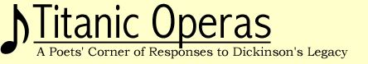
THE DARKEST GUSH: EMILY DICKINSON AND THE TEXTUAL MARK
by Rachel Blau DuPlessis
Page 1
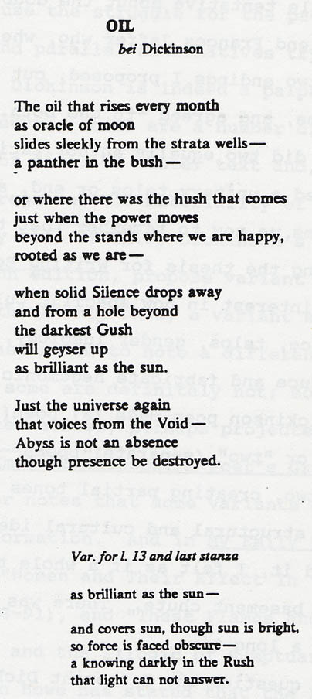
In August and September 1978, in the final stage of a long struggle to complete and shape my first book, Wells (Montemora 1980), I wrote a poem called "Oil." It carried a dedicatory note, "bei Dickinson." The "bei"--which I meant to be Yiddish even more than German--was particularly impudent, coming from the unassimilated immigrant language of my cultural Judaism, punning on "by," as if Emily Dickinson were the author of my work, but supposedly just meaning "near" or "next to." When the poem appeared in Wells (1980), it faced a poem called "Nessie," about the Loch Ness monster, another poem about female power, this one subtitled "for Woolf."
"Oil" was meant seriously and from its inception as direct homage to Dickinson's textual practices. "Tremendous idea about 'Oil' [I recorded in my journal in September 1978]--write it in two versions! Do an 'alternative'--a second ending just like Dickinson." The "tremendousness" of the idea was not, as it turned out, just cloying or self-cheering overstatement. It was an idea with many implications that has continued to affect my work and reverberate within it.
I was a little tentative about the double ending and remember talking to my friend, Frances Jaffer, who, when faced with my delicate query about the two endings I proposed, cut through my fear, reflected my risk back to me, and agreed "to use both." With the dual ending, I got a text which did two equally authoritative things, and which therefore ruptured a unitary telos, or end, and refused single-minded ending. It charms me now to remember that this was about the time that I was constructing the thesis for Writing Beyond the Ending (Indiana UP 1985), with its interest in how specific cultural mechanisms like narrative sequence, telos, gender ideology, and heterosexual assumptions produce and fabricate hegemonic plot. Further, the double ending of the Dickinson poem made (a) poem(s) that isn't/aren't either "one" (unified) or "two" (separate) poems--thus oscillating between and across one and two, creating partial tones and new integers. Because of the powerful structural and cultural ideas foregrounded by the poem, when I completed it, I felt as if a whole ton of coal had been poured noisily down my basement chute. There was a lot to "burn," and, as it turned out, for a long time.
I began to question why I thought Dickinson made such texts, and to follow the logic of Dickinson's textual critique in my own poems. This work was joined with and implicated in my own feminism. The poems I wrote with both disturbance of the culture and the page in mind are not indebted solely or totally to Dickinson: William Carlos Williams, George Oppen, H.D., other modernist writers, and contemporary innovative writers are all sources. But I considered my page space practices as a feminism of the text because of their disturbance of poetry-as-usual, because the struggle for the page is made visible, because conflicting and parallel alternatives try to exist on the same page space. For this, Dickinson is indeed a palpable source.
In Dickinson's oeuvre, there are a number of texts which destabilize the idea of final or master text and, by virtue of the textual practices, foreground the materiality of the visual text. Some (though in fact hardly all) of Emily Dickinson's poems, as we learned from the Thomas Johnson edition, propose variant words, sometimes variant lines, and, I think only once, a variant stanza. At certain key moments, she seemed fascinated to note a different word. Some are virtually synonymous; some are definitely not; some seem more radical; and some, more nice alternatives, perhaps projected with different readers in mind. . . .
In proposing, recording, registering the alternative words (whether synonymous or contrastive), Dickinson was registering several deep facts about the profession or practices of poetry. First, when writing, one is intensely inside language. Playing with the medium, one admires both it and one's own power in seeing how individual words change weights, balances, forces, and vectors. Not for nothing did Dickinson note to Higginson that her companion was Noah Webster. The dictionary, perhaps, was her mysterious Master. . . .
I became convinced that Dickinson wanted the alternative as such. By disturbing the axis of selection and the notion of equivalence, she wanted to break the iconicity of a one-way text. Of course a (normal) poem must have only one word in any one spot! Of course a (real) poem couldn't have two words in one place! Yet Dickinson's did. In a poem, every mark has meaning. If there are alternative marks for the same place in the poem, meaning is destabilized, rendered at least momentarily undecidable, jostled, made both more complex and even permanently unfixed
. . . .

