Gertrude Stein Assemblage

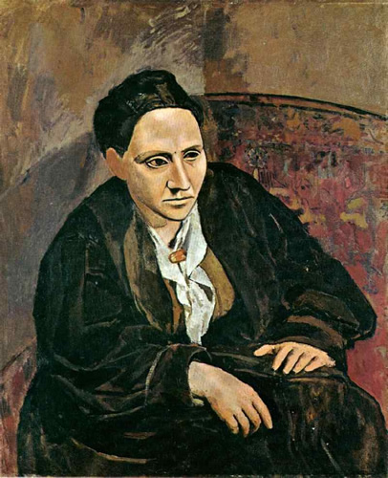
Picasso | Portrait of Gertrude Stein

1. What is identity and why is there so much of it?
Any cultural production can be viewed through the lens of its socio-historical circumstance. To ignore such contexts is to deny the social truths of the work. Yet such contexts are inadequate to establish a work's identity. [....]Stein's puppet show shows identity as an acting out rather than as an inner state; externally animated, not innately fixed.
Stein did not narrativize her otherness any more than she naturalized it, and that makes her a suitably uncomfortable subject for those who would read her in terms of group-identity poetics. Stein's work eludes thematic and biographist projections in its demonstration that forms, structures, syntax, and style may also signify identity's puppet show. This may begin to account for how Stein's triple distance from the ascendant culture (gender, sexual orientation, ethnicity) is related to her radical breaks from traditional notions of meaning, literary tradition, explanation, and linearity.
Stein questions identity constructions; she does not affirm identity. Her syntactic and grammatical investigations show how language forms consciousness, how our words make as well as reflect experience. – Charles Bernstein, “Stein’s Identity”
2. Reading as Dialogue -
A language tries to be free.
Reading.
To think it through from the extremes or the exceptions, what better place to start than with Gertrude Stein.
The words don't take the place of a prior reality. Material insistence triumphs, slipping and sliding beneath the sign.[. . . .]
Now we make mischief.
Doing away with illusions of naturalness, without nodding our head in recognition.
We have been baffled by harmony.
Thank you for the meaning of reading. Read aloud.
Leave eye lessons I.
Leave I. Lessons. I.
Leave I lessons, I.
Listen to the addresses.
The text's social address:
Its immediacy to our senses helps to produce a Real, not to concoct an incorporeal simulacra of theatrical presence.
I wish bursts.
I meant to be told.
It's an anti-overhearing.
Instead of pretending to offer an unmediated picture or a vista of what's outside itself, it operates on us, sounds and resounds us, unmediatedly itself, publicly. - Bruce Andrews, Reading Language, Reading Gertrude Stein

3. Everything I have done has been influenced by Flaubert and Cezanne, and this gave me a new feeling about composition. Up to that time composition had consisted of a central idea, to which everything else was an accompaniment and separate but was not an end in itself, and Cezanne conceived the idea that in composition one thing was as important as another thing. Each part is as important as the whole, and it impressed me enormously, and it impressed me so much that I began to write Three Lives under this influence.[…]
You see I tried to convey the idea of each part of a composition being as important as the whole. […] it was not solely the realism of the characters but the realism of the composition which was the important thing, the realism of the composition of my thoughts. [....]
I began to play with words then. I was a little obsessed by words of equal value. Picasso was painting my portrait at that time, and he and I used to talk this thing over endlessly. At this time he had just begun on cubism. . . . I took individual words and thought about them until I got their weight and volume complete and put them next to another word, and at this same time I found out very soon that there is no such thing as putting them together without sense. I made innumerable efforts to make words write without sense and found it impossible. Any human being putting down words had to make sense out of them. . . . It should create a satisfaction in the mind of the reader but in the same image as the creation.—Gertrude Stein ("A Transatlantic Interview—1946," in A Primer for the Gradual Understanding of Gertrude Stein. Ed. Robert Bartlett Haas.)
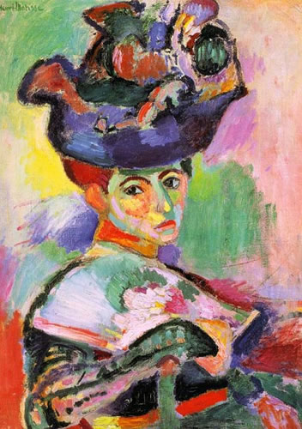
Matisse | La Femme au Chapeau
4. If the attention could envision the whole of writing, let us say, at one time, moving over it in swift and accurate pursuit of the modern imperative at the instant when it is most to the fore, something of what actually takes place under an optimum of intelligence could be observed. It is an alertness not to let go of a possibility of movement in our fearful bedazzlement with some concrete and fixed present[. . . .]
Writing, like everything else, is much a question of refreshed interest. It is directed, not idly, but as most often happens (though not necessarily so) toward that point not to be predetermined where movement is blocked (by the end of logic perhaps). It is about these parts, if I am not mistaken, that Gertrude Stein will be found.
"Melanctha" is a thrilling clinical record of the life of a colored woman in the present-day United States, told with directness and truth. It is without question one of the best bits of characterization produced in America. It is universally admired. This is where Stein began. But for Stein to tell a story of that sort, even with the utmost genius, was not enough under the conditions in which we live, since by the very nature of its composition such a story does violence to the larger scene which would be portrayed.- "The Work of Gertrude Stein," William Carlos Williams
5. Sentences and Paragraphs
In a book I wrote called How to Write I made a discovery which I considered fundamental, that sentences are not emotional and that paragraphs are. I found out about language that paragraphs are emotional and sentences are not and I found out something else about it. I found out that this difference was not a contradiction but a combination and that this combination causes one to think endlessly about sentences and paragraphs because the emotional paragraphs are made up of unemotional sentences. - Stein, Lectures in America

6. Repetition
Remembering is repetition anybody can know that. In doing a portrait of any one, the repetition consists in knowing that that one is a kind of a one, that the things he does have been done by others like him that the things he says have been said by others like him, but, and this is the important thing, there is no repetition in hearing and saying the things he hears and says when he is hearing and saying them. And so in doing a portrait of him if it were possible to make that portrait a portrait of him saying and hearing what he says and hears while he is saying and hearing it there is then in so doing neither memory nor repetition no matter how often that which he says and hears is heard and said.- Stein, Lectures in America

7. Identity
The thing one gradually comes to find out is that one has no identity that is when one is in the act of doing anything. Identity is recognition, you know who you are because you and others remember anything about yourself but essentially you are not that when you are doing anything. I am I because my little dog knows me but, creatively speaking the little dog knowing that you are you and your recognizing that he knows, that is what destroys creation. That is what makes school. Picasso once remarked I do not care who it is that has or does influence me as long as it is not myself. [. . . .]
It has been said of geniuses that they are eternally young. I once said what is the use of being a boy if you are going to grow up to be a man, the boy and the man have nothing to do with each other, except in respect to memory and identity, and if they have anything to do with each other in respect to memory and identity then they will never produce a master-piece. Do you do you understand well it really does not make much difference because after all master-pieces are what they are and the reason why is that there are very few of them. The reason why is any of you try it just not to be you are you because your little dog knows you. The second you are you because your little dog knows you you cannot make a master-piece and that is all of that.
It is not extremely difficult not to have identity but it is extremely difficult the knowing not having identity. One might say it is impossible but that it is not impossible is proved by the existence of master-pieces which are just that. They are knowing that there is no identity and producing while identity is not.
That is what a master-piece is. - From "What Are Master-pieces and Why Are There So Few of Them" Gertrude Stein
8. The characteristic quality of a classic is that it is beautiful. Now of course it is perfectly true that a more or less first rate work of art is beautiful but the trouble is that when that first rate work of art becomes a classic because it is accepted the only thing that is important from then on to the majority of the acceptors the enormous majority, the most intelligent majority of the acceptors is that it is so wonderfully beautiful. Of course it is wonderfully beautiful, only when it is still a thing irritating annoying stimulating then all quality of beauty is denied to it.
Of course it is beautiful but first all beauty in it is denied and then all the beauty of it is accepted. If every one were not so indolent they would realize that beauty is beauty even when it is irritating and stimulating not only when it is accepted and classic. Of course it is extremely difficult nothing more so than to remember back to its not being beautiful once it has become beautiful. This makes it so much more difficult to realize its beauty when the work is being refused and prevents every one from realizing that they were convinced that beauty was denied, once the work is accepted. Automatically with the acceptance of the time sense comes the recognition of the beauty and once the beauty is accepted the beauty never fails any one.
Beginning again and again is a natural thing even when there is a series.
Beginning again and again and again explaining composition and time is a natural thing.[...]
The composition is the thing seen by every one living in the living that they are doing, they are the composing of the composition that at the time they are living is the composition of the time in which they are living. It is that that makes living a thing they are doing. Nothing else is different, of that almost any one can be certain. The time when and the time of and the time in that composition is the natural phenomena of that composition and of that perhaps every one can be certain.
No one thinks these things when they are making when they are creating what is the composition, naturally no one thinks, that is no one formulates until what is to be formulated has been made. [....]
Naturally one does not know how it happened until it is well over beginning happening.
Each period of living differs from any other period of living not in the way life is but in the way life is conducted and that authentically speaking is composition. - "Composition as Explanation" Gertrude Stein
9. A second constant in Stein's style is the pronounced repetition of words, phrases, and sentences, with no change or with only incremental progressions of sounds or associations. Works such as The Making of Americans and Three Lives contain long passages in which each sentence is a light variation on some core phrase. with great repetition of words even within a single sentence. Stein termed this phenomenon "insistence" rather than repetition, citing her former teacher, William James, as her philosophical authority. James's argument in his The Principles of Psychology (1890) that one must think of the identical recurrence of a fact in a fresh manner remarkably resembles Stein's contention that "in expressing anything there can be no repetition because the essence of that expression is insistence, and if you insist you must each time use emphasis and if you use emphasis it is not possible while anybody is alive that they should use exactly the same emphasis." Repetition or insistence is perhaps the central aspect of what has been called Stein's "cinema style," based on her claim that in writing The Making of Americans she was "doing what the cinema was doing." She added that her writing in that book was "like a cinema picture made up of succession and each moment having its own emphasis that is its own difference and so there was the moving and the existence of each moment as it was in me." [....]
From James at Harvard and possibly from Henri Bergson in Paris, Stein had learned that the best model for human consciousness was one that stressed the processual, ever-flowing nature of experience. She added to this belief her assumption that the essence of any subject could only be perceived and should only be represented through its motion, echoing Bergson's claim that "reality is mobility."[....]

Three Lives is easily Stein's best-known and most respected piece of:fiction. Technically three novellas, this work is unified by its three subjects, by its central concern with the nature of consciousness, and by its attempt to blend colloquial idioms with Stein's emerging style. here based largely on her understanding of Cezanne's principles of composition, particularly that "one thing was as important as another thing." "The Good Anna," "Melanctha," and "The Gentle Lena" are the three sections of this work. Anna and Lena are poor German immigrants who patiently work as servants in Bridgepoint. Baltimore: Melanctha is a young black woman who discovers sexuality and love, then turns from a frustrating relationship with a sincere young black doctor to a dissipative affair with a gambler. Since all three women are essentially victimized by their surroundings and die at the end of their stories, this work is deterministic in the naturalist tradition, but Three Lives marks the transition from naturalism to modernism as Stein departs from nineteenth century literary conventions. She abandons conventional syntax to try to follow the movement of a consciousness rather than of events, and she develops a new narrative style only partially tied to linear chronology. The result is an interior narrative of consciousness in which Stein's prose style serves as the primary carrier of knowledge. Through the rhythms of her characters' speech and the rhythms of her narration, Stein gives her reader a sense of the basic rhythms of consciousness for these three women--what Stein would elsewhere refer to as their "bottom natures." – Brooks Landon, http://www.english.uiowa.edu/faculty/landon/brooks/stein.html

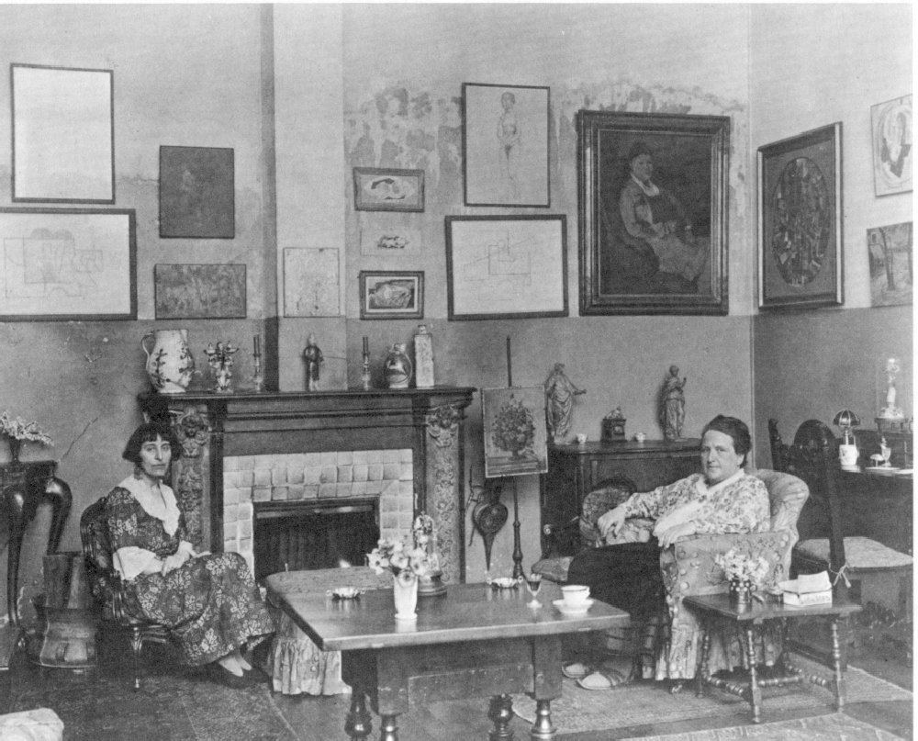
Alice B. Toklas & Gertrude Stein, studio at 27 Rue de Fleurus, Paris. 1922.

